Clean Up and Push to Remote Repository

Aim:
To verify the repository status, synchronize the local repository with the remote repository, and push the latest changes to GitHub.
Tools Required:
- Git Bash
- GitHub
- Windows PC
- Existing Git Repository (GitDemo)
Procedure:
- Verify that the local repository is in a clean state.
- List all available branches.
- Pull the latest changes from the remote repository.
- Push any pending changes to the remote repository.
- Verify that the latest changes are reflected in GitHub.
Commands Used:
cd ~/GitDemo
git status
git branch -a
git pull origin main
git push origin main

Fig. 1: Output of git status showing the repository is in a clean state.
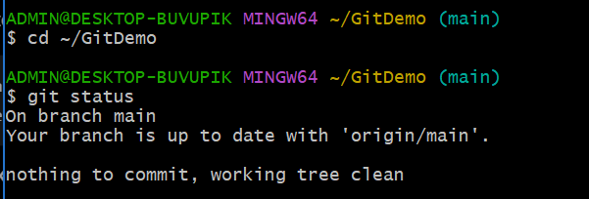

Fig. 2: Output of git branch -a displaying local and remote branches.
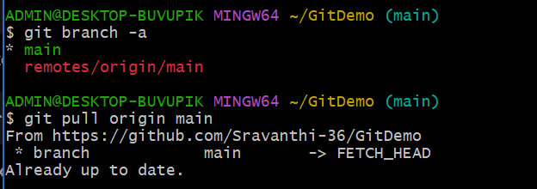

Fig. 3: Successful execution of git pull origin main.
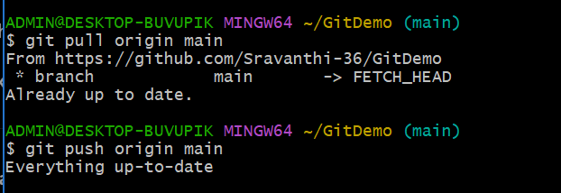

Fig. 4: GitHub repository showing the latest files (welcome.txt, .gitignore, branch.txt, and hello.xml).
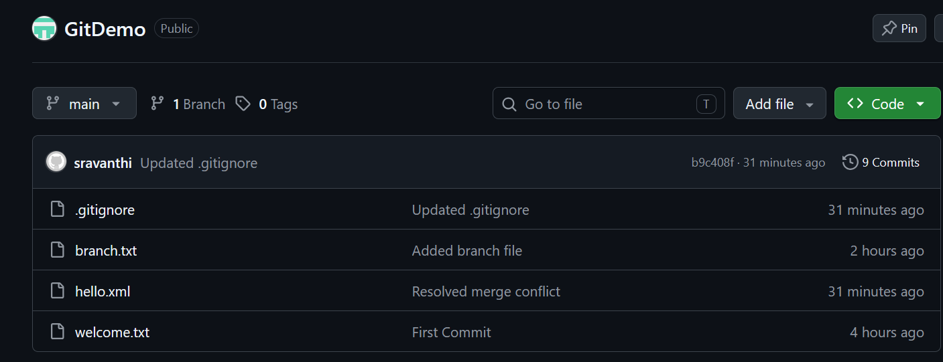
Result:
Successfully verified the repository status, synchronized the local repository with the remote repository, pushed the latest changes, and confirmed that all files were updated in the GitHub repository.

